|  |  |  |
| --- | --- | --- |
| SCHOOL OF INFORMATION AND TECHNOLOGY | | |
| NAME: Zhaun Gabrielle F. Pasion | DATE PERFORMED: 26/9/24 | /50 |
| Section: IDC2 | DATE SUBMITTED: 26/9/24 |

# SYSADM1 – Monitoring Print Services in Windows Server 2019

# Requirement:

* A virtual machine running Linux and Windows OS

Part 1: Setting Up Print Services

1. Install and configure **print.srv** domain



1. Connect one client to the recently created domain

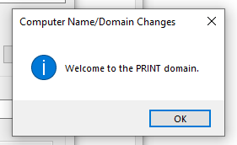

1. Install Print Services Role:

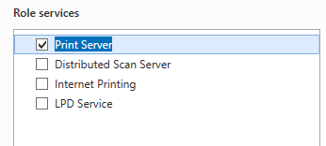

1. Search the internet for any printer installer and convert it to iso





1. Install and deploy it as network printer

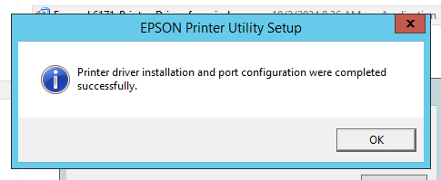

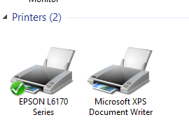

Part 2: Monitoring Print Services

Objective: Familiarize yourself with monitoring tools available in Windows Server 2019.

1. Event Viewer:
   * Open Event Viewer (run eventvwr.msc).

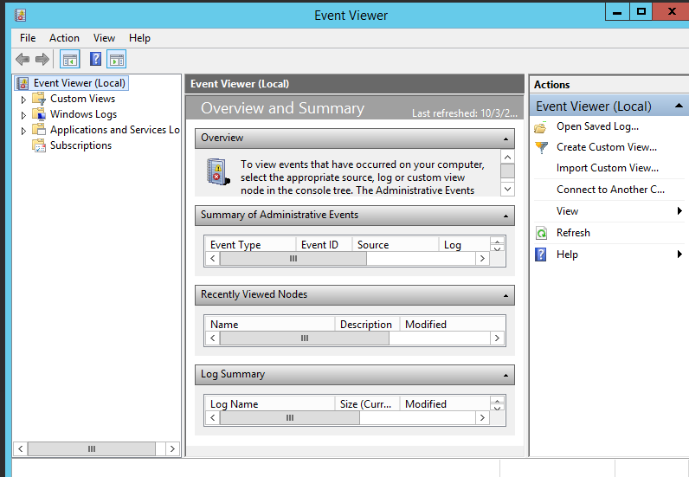

* + Navigate to Applications and Services Logs > Microsoft > Windows > PrintService.

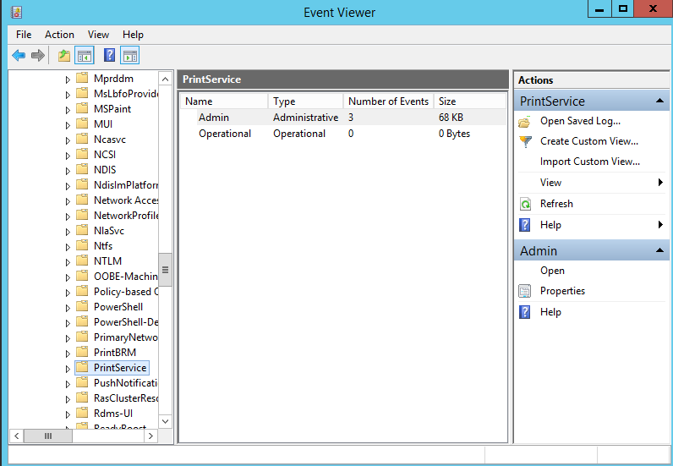

* + Review logs for print jobs, errors, and warnings.

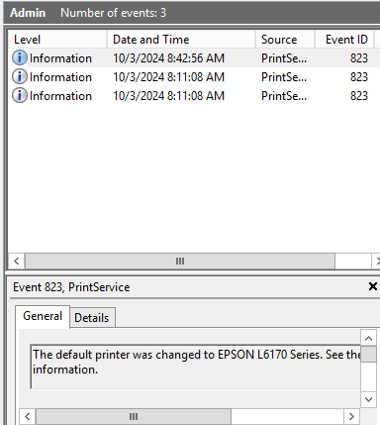

New printer was set to as default printer

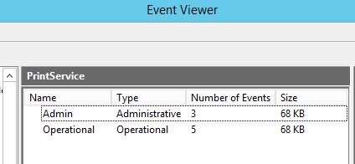

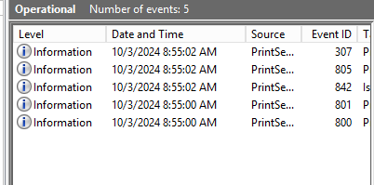

Even logs updated after printing a document

1. Performance Monitor:
   * Open Performance Monitor (run perfmon).

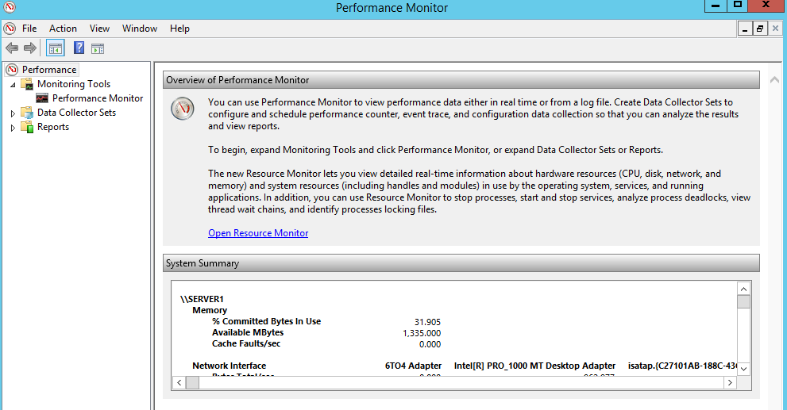

* + In the left pane, expand Data Collector Sets > System.

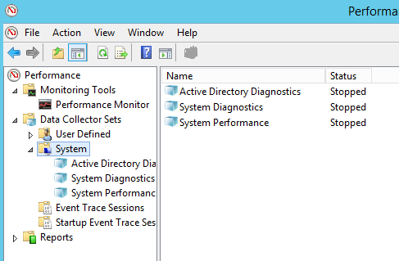

* + Right-click System Performance and select Start.

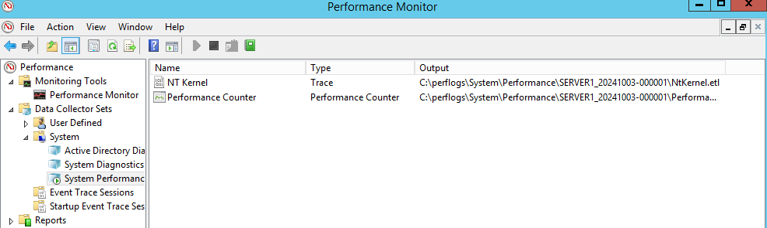

* + Monitor performance metrics related to print services.

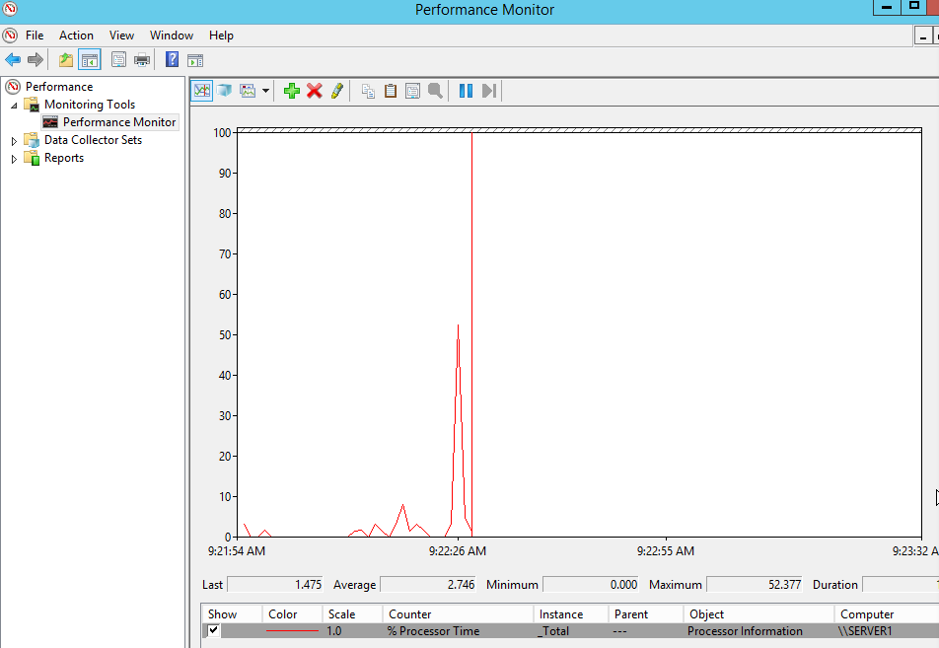

Line have spiked up after printing a document

1. Using Print Management Console:
   * Open Print Management from Server Manager.

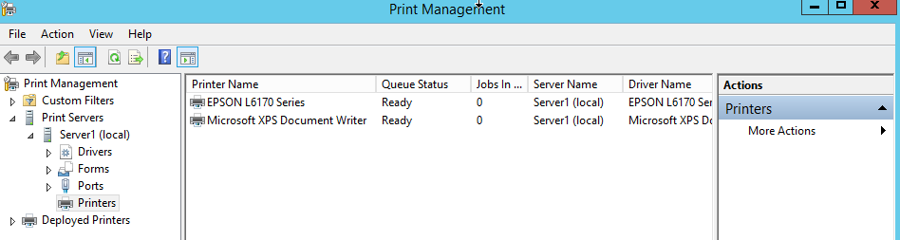

* + View active print jobs and their status.

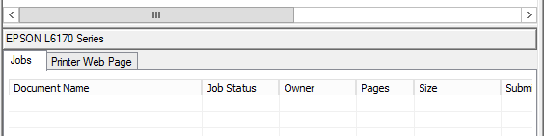

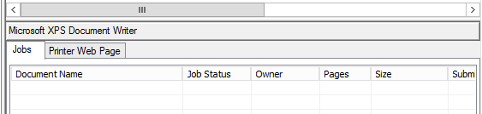

Both active printers are not printing anything at the moment

* + Use the Printers node to check the status of all printers.

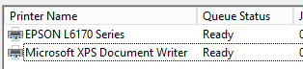

Both printers are ready for printing

Part 3: Exploring Third-Party Monitoring Tools

1. Research at least two third-party print monitoring tools
   * Consider factors such as features, pricing, and compatibility with Windows Server 2019

|  |  |
| --- | --- |
| **PaperCut NG** | |
| Features | * Suitable for networks from 5 to 500,000+ users. * Suitable for single server environments to multi-server, multi-site and clustered environments. * Capable of monitoring locally attached or workgroup printers. * International: Available in 20+ languages and currency formats worldwide. * Almost all major laser, inkjet, label and wide-format printers/MFDs/plotters. * Supported print languages: PCL, PCL6, HPGL, PostScript, PCL-GUI, |
| Pricing | Commercial – Free to $930  Professional - $692 to $1712  Educational – Free to $1385 |
| Compatibility | Compatible with Server 2019 |

|  |  |
| --- | --- |
| **Print Inspector** | |
| Features | * Detailed information on the documents printed by remote users (includes document name, number of pages and other parameters) * Reports and statistical data * Ability to export data for further processing * Printer queue management * Easy management and access to printer and print server settings * Makes no changes to your system files, configurable to load on Windows start-up |
| Pricing | Free |
| Compatibility | Compatible with Server 2019 |

**Comparison**

* **User Capacity:** PaperCut supports networks from 5 to 500,000+ users, while Print Inspector's capacity is not specified but likely focuses on remote user monitoring.
* **Environment**: PaperCut is suitable for single to multi-server, multi-site, and clustered environments, whereas Print Inspector primarily manages printer queue and auditing.
* **Printer Monitoring:** PaperCut monitors locally attached or workgroup printers, while Print Inspector records detailed information about all printed documents, including user and computer details.
* **Language Support:** PaperCut is available in 20+ languages and currency formats, while Print Inspector does not specify language support.
* **Printer Compatibility:** PaperCut supports almost all major printers, while Print Inspector is compatible with various printers and plotters.
* **Supported Print Languages:** PaperCut supports several print languages (PCL, PCL6, HPGL, PostScript, PCL-GUI), while Print Inspector does not specify supported print languages.
* **Export Data:** PaperCut does not mention export capabilities, while Print Inspector allows data export for further processing.
* **Queue Management:** Queue management is implied for PaperCut, while Print Inspector offers dedicated management features for print jobs in the queue.
* **System Impact**: PaperCut may change system files, whereas Print Inspector makes no changes to system files and can load on Windows start-up.
* **License:** PaperCut has a commercial pricing structure, while Print Inspector is available as freeware.
* **Discontinuation:** PaperCut is an active product, while Print Inspector is discontinued with no further updates or support.

1. Install and Configure:
   * Choose one of the tools to install in your environment.





* + Follow the installation instructions provided by the tool's documentation.

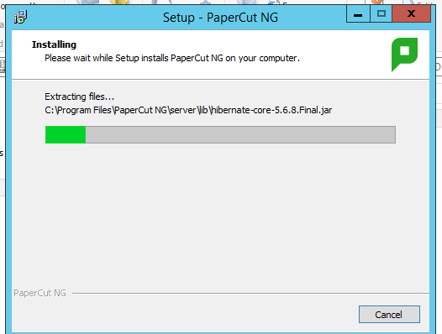

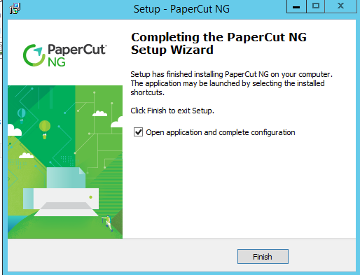

* + Configure it to monitor your print services.

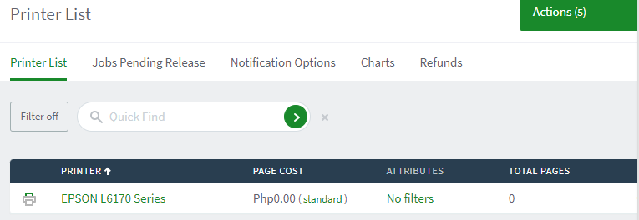

1. Test and Report Findings:
   * Generate a report or dashboard from the tool.

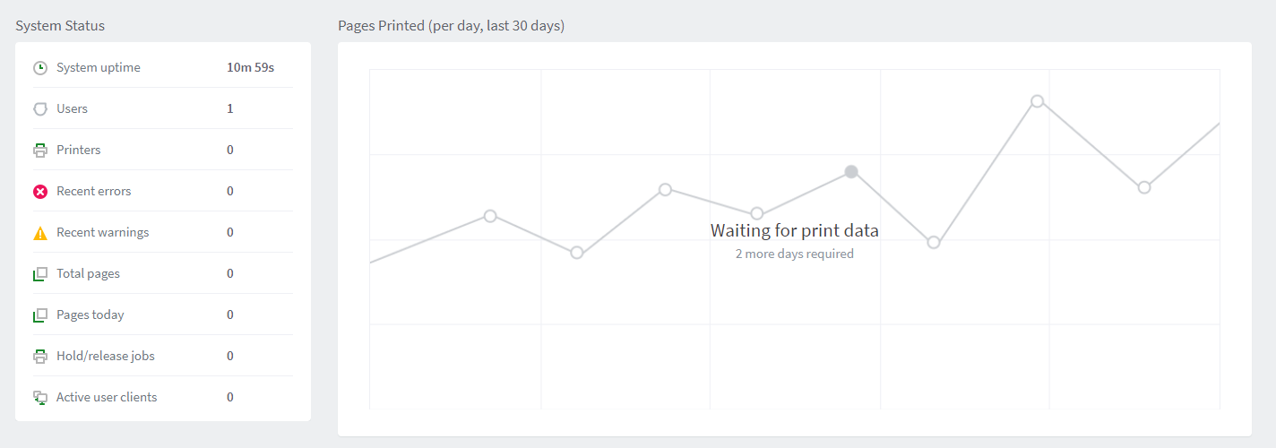



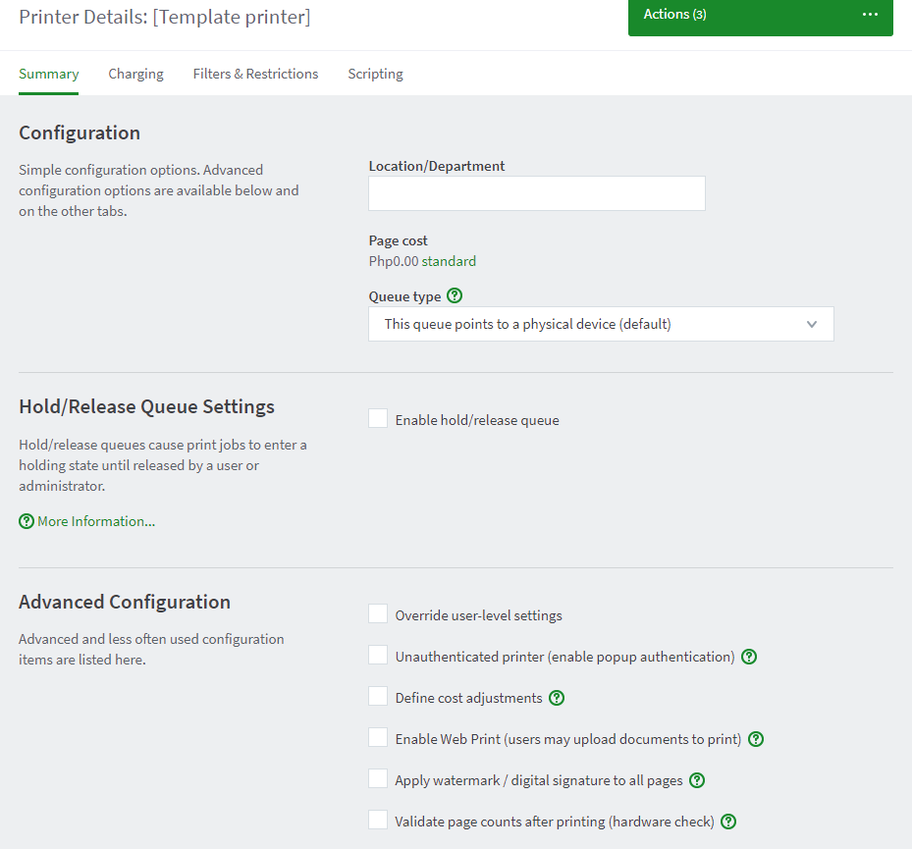

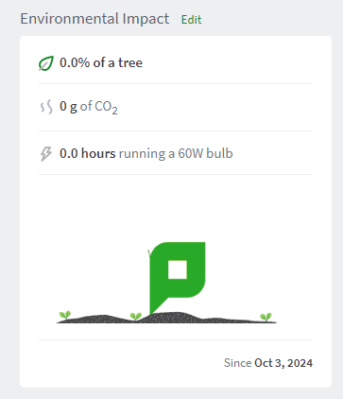

Report:

System uptime: 10m and 59s (Started after installation)

Data: No data acquired, need to wait 2 days to gather and compute data

Printer: EPSON printer installed as default in the third party app

Pricing: The app features a pricing system for printing

The app has an environmental feature

* + Analyze the collected data (e.g., print volume, errors, user activity).

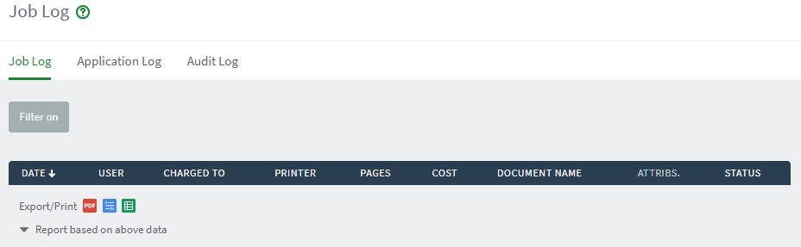

Job Logs: No documents Printed yet

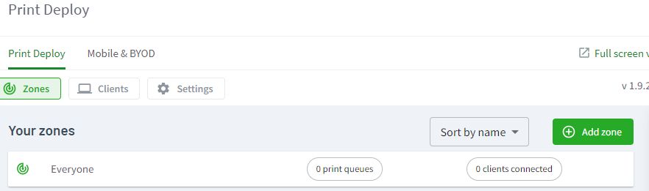

Everyone connected to the server can print.

Print Que: 0, no printing ques at the moment

REFERENCES:

SoftPerfect Print Inspector : printer usage monitoring and audit. (n.d.). https://www.softperfect.com/products/pinspector/

Thank you. (n.d.). PaperCut. https://www.papercut.com/thank-you/ng/?submissionGuid=2d313352-1bba-4fdd-9a01-11c14e1ff333

PrinterDrivers.com. (n.d.). https://printerdrivers.com/epson-l6171-driver/#windows

Rubric

| **Criteria** | **1 (Unsatisfactory)** | **2 (Needs Improvement)** | **3 (Satisfactory)** | **4 (Good)** | **5 (Excellent)** | **Score** |
| --- | --- | --- | --- | --- | --- | --- |

|  |  |  |  |  |  |  |
| --- | --- | --- | --- | --- | --- | --- |
| **Part 1: Setting Up Print Services** |  |  |  |  |  |  |

|  |  |  |  |  |  |  |
| --- | --- | --- | --- | --- | --- | --- |
| **Domain Installation** | No domain created | Domain created with errors | Domain created correctly | Domain configured well | Domain configured and documented thoroughly |  |

|  |  |  |  |  |  |  |
| --- | --- | --- | --- | --- | --- | --- |
| **Client Connection** | Client not connected | Connection attempt failed | Client connected but with issues | Client connected correctly | Client connected and documented well |  |

|  |  |  |  |  |  |  |
| --- | --- | --- | --- | --- | --- | --- |
| **Print Services Role Installation** | Role not installed | Role installed with issues | Role installed correctly | Role installed and configured | Role installed, configured, and documented thoroughly |  |

|  |  |  |  |  |  |  |
| --- | --- | --- | --- | --- | --- | --- |
| **Printer Installer Conversion** | No installer found | Installer conversion attempted but failed | Installer converted but not used | Installer converted and used | Installer converted, used, and documented well |  |

|  |  |  |  |  |  |  |
| --- | --- | --- | --- | --- | --- | --- |
| **Network Printer Deployment** | Printer not deployed | Deployment failed | Printer deployed but not functional | Printer deployed correctly | Printer deployed, tested, and documented well |  |

|  |  |  |  |  |  |  |
| --- | --- | --- | --- | --- | --- | --- |
| **Part 2: Monitoring Print Services** |  |  |  |  |  |  |

|  |  |  |  |  |  |  |
| --- | --- | --- | --- | --- | --- | --- |
| **Event Viewer Usage** | Event Viewer not opened | Opened but no logs reviewed | Logs reviewed but superficial | Logs reviewed with some analysis | Logs reviewed with thorough analysis and documentation |  |

|  |  |  |  |  |  |  |
| --- | --- | --- | --- | --- | --- | --- |
| **Performance Monitor Usage** | Performance Monitor not opened | Opened but no metrics monitored | Metrics monitored but not analyzed | Metrics monitored with some analysis | Metrics monitored, analyzed, and documented thoroughly |  |

|  |  |  |  |  |  |  |
| --- | --- | --- | --- | --- | --- | --- |
| **Print Management Console Usage** | Console not opened | Opened but functionality not used | Active jobs viewed superficially | Active jobs viewed with some detail | Active jobs viewed and documented thoroughly |  |

|  |  |  |  |  |  |  |
| --- | --- | --- | --- | --- | --- | --- |
| **Part 3: Exploring Third-Party Tools** |  |  |  |  |  |  |

|  |  |  |  |  |  |  |
| --- | --- | --- | --- | --- | --- | --- |
| **Research on Tools** | No tools researched | Research incomplete | Research on one tool completed | Research on two tools with some analysis | Research on two tools, detailed analysis, and comparison |  |

|  |  |  |  |  |  |  |
| --- | --- | --- | --- | --- | --- | --- |
| **Installation and Configuration** | Tool not installed | Installation failed | Tool installed but not configured | Tool installed and configured with issues | Tool installed, configured, and documented thoroughly |  |

|  |  |  |  |  |  |  |
| --- | --- | --- | --- | --- | --- | --- |
| **Reporting Findings** | No report generated | Report lacks detail | Report generated but lacks analysis | Report generated with some analysis | Comprehensive report with thorough analysis and documentation |  |